

Xpert® HBV Viral Load

GXHBV-VL-CE-10

Instructions for Use

2797

In Vitro Diagnostic Medical Device
302-6823, Rev. A
04-2026

Trademark, Patents and Copyright Statements
Cepheid®, the Cepheid logo, GeneXpert®, and Xpert® are trademarks of Cepheid, registered in the U.S. and other countries. All other trademarks are the property of their respective owners.
THE PURCHASE OF THIS PRODUCT CONVEYS TO THE BUYER THE NON-TRANSFERABLE RIGHT TO USE IT IN ACCORDANCE WITH THESE INSTRUCTIONS FOR USE. NO OTHER RIGHTS ARE CONVEYED EXPRESSLY, BY IMPLICATION OR BY ESTOPPEL. FURTHERMORE, NO RIGHTS FOR RESALE ARE CONFERRED WITH THE PURCHASE OF THIS PRODUCT.

© 2018-2026 Cepheid.
See Section 26, Revision History for a description of changes.

Xpert® HBV Viral Load

For In Vitro Diagnostic Use.

Proprietary Name
Xpert® HBV Viral Load

Common or Usual Name
Xpert HBV VL

Intended Purpose

Intended Use
The Xpert® HBV Viral Load test, performed on GeneXpert® systems, is an automated, quantitative in vitro diagnostic real-time polymerase chain reaction (PCR) test for quantitation of Hepatitis B Virus (HBV) DNA in human serum or plasma (EDTA) from chronically HBV-infected individuals.

The test is intended for use in conjunction with clinical presentation and other laboratory markers as an indicator of disease prognosis and for use as an aid in assessing viral response to antiviral treatment as measured by changes in plasma or serum HBV DNA levels.

The test is not intended to be used as a donor screening test for HBV, or to be used as a diagnostic test to confirm the presence of HBV infection.

The intended patient population is chronically-HBV infected adults, who have been previously diagnosed with HBV.

Intended User/Environment
The Xpert HBV Viral Load test is intended to be performed by healthcare professionals trained on the use of the test. This test is for use in a laboratory environment.

Summary and Explanation
HBV is a small, enveloped DNA virus in the family Hepadnaviridae and is responsible for acute and chronic HBV hepatitis. The virus has a small circular DNA genome that is partially double-stranded, partially single-stranded, and is 42nm in diameter. HBV contains numerous antigenic components which include hepatitis B surface antigen (HBsAg), hepatitis
B core antigen (HBcAg), and hepatitis B e antigen (HBeAg). HBV is transmitted by percutaneous or mucosal exposure to the blood or body fluids of an infected person, from an infected mother to her newborn, through close contact within
households, through unscreened blood transfusion or unsafe injections in healthcare settings, through injection drug use, and from sexual contact with an infected person.
Chronic Hepatitis B (CHB) may present either as HBeAg-positive or HBeAg-negative CHB. Age-specific HBsAg seroprevalence varies markedly by geographical region, with the highest prevalence (>5%) in sub-Saharan Africa, East Asia, some parts of the Balkan regions, the Pacific Islands and the Amazon Basin of South America. Prevalence below 2% is seen in regions such as Central Latin America, North America and Western Europe. Overall, almost half of the global population lives in areas of high endemicity.1 Morbidity and mortality of CHB are linked to persistence of viral replication and evolution to cirrhosis and/or hepatocellular carcinoma (HCC).2 Mortality from viral hepatitis has increased over time and will continue to rise unless people are diagnosed and treated.3

HBV vaccine is available for infants and has considerably reduced the number of new chronic infections but coverage is only 39%.3 In 2015, 3.5% of the world’s population was living with chronic HBV infection with the Western Pacific and African regions being the most heavily affected areas.3 Only 9% of those with HBV knew their diagnosis, and of those diagnosed, only 8% were receiving therapy.3 Nucleoside and nucleotide analogues, such as tenofovir and entecavir, are recommended for those eligible for therapy as these antiviral agents are effective at suppressing HBV replication, preventing progression to cirrhosis, and reducing liver-related deaths.1 Therapy for HBV is continued lifelong.1

Principle of the Procedure
The Xpert HBV VL test is an automated test for quantitative detection of HBV. The test is performed on the Cepheid GeneXpert and GeneXpert Infinity Instrument Systems.
The GeneXpert Instrument Systems automate and integrate sample purification, nucleic acid amplification, and detection of the target sequence in simple or complex samples using real-time PCR. The systems consist of an instrument, a personal computer and preloaded software for running tests and viewing the results. The systems require the use of single-use disposable GeneXpert cartridges that hold the PCR reagents and host the purification and PCR processes. Because the
cartridges are self-contained, cross-contamination between samples is minimized. For a full description of the systems, refer to the appropriate GeneXpert Dx System Operator Manual or GeneXpert Infinity System Operator Manual.
The Xpert HBV VL test includes reagents for the detection of HBV DNA in specimens as well as two internal controls used for quantitation of HBV DNA. The internal controls are also used for adequate processing of the target and to monitor the presence of inhibitor(s) in the PCR reactions. Amplification and detection of HBV DNA is achieved by primers and probes targeted to the highly conserved part of the preCore/Core promotor region. The amplified target DNA of HBV and the internal controls are detected using probes labeled with a fluorescent-dye. The amplification cycle at which the fluorescent- dye signal is above a certain threshold determines the cycle threshold (Ct). The HBV Ct is proportional to the log of the HBV DNA concentration present in the specimen. The Probe Check Control (PCC) verifies reagent rehydration, PCR tube filling in the cartridge, probe integrity, and dye stability.
The Xpert HBV VL test result is traceable to the 4th World Health Organization (WHO) International Standard for HBV DNA for Nucleic Acid Amplification Technologies (NAT) (NIBSC code: 10/266).4

Reagents and Instruments

Materials Provided
The Xpert HBV VL test kit contains sufficient reagents to process 10 specimens and/or quality control samples. The kit contains the following:

Xpert HBV VL with Integrated Reaction Tubes |  | 10
Component/Reagent | Ingredient | Amount
Beads (freeze-dried) | Enzyme: polymerase <5% | 3 per cartridge
 | dNTPs <5%
 | Primers and probes <5%
 | IQS High DNA <5%
 | IQS Low DNA <5%
Protein stabilizer – bovine origin
<5%
 | PCR buffer <5%
 | Precipitating agent <5%
Reagents | Guanidinium thiocyanate <20% | 5.7 mL per cartridge
 | Salt <5%
 | Chemical preservative <5%
 | Binding Reagent <50%
 | Detergent <5%
 | Proteinase K <5%
 | Tris buffer <5%

Disposable 1 mL Transfer Pipettes 10 per kit
CD 1 per kit
- Assay Definition File (ADF)
- Instructions to Import ADF into GeneXpert and Infinity Software
- Instructions for Use (Package Insert)

Safety Data Sheets (SDS) are available at www.cepheid.com or www.cepheidinternational.com under the SUPPORT
tab.
Note

The protein stabilizer of bovine origin, in the beads within this product was produced and manufactured exclusively from
Note bovine plasma sourced in the United States. No ruminant protein or other animal protein was fed to the animals; the animals passed ante- and post-mortem testing.

Storage and Handling
- Store the Xpert HBV VL cartridges at 2–35 °C until the expiration date provided on the label.
- Bring the cartridges to room temperature prior to use if they have been stored cold.
- Do not use cartridges that have passed the expiration date.
- Do not open a cartridge lid until you are ready to perform testing.
- Do not use a cartridge that has leaked.

Materials Required but Not Provided
- GeneXpert® Dx Instrument System or GeneXpert® Infinity Instrument System (catalog number varies by configuration): GeneXpert instrument, computer with proprietary GeneXpert Software Version 4.7b or higher (GeneXpert Dx systems) or Xpertise 6.4b or higher (Infinity-80/Infinity-48s), barcode scanner, and appropriate GeneXpert Instrument System operator manual.
- Printer: If a printer is needed, contact Cepheid Technical Support to arrange for the purchase of a recommended printer.
- Bleach or sodium hypochlorite
- Denatured ethanol

Warnings and Precautions

General
- For in vitro diagnostic use.
- Treat all biological specimens, including used cartridges, as if capable of transmitting infectious agents. Because it is often impossible to know which might be infectious, all biological specimens should be treated with standard
precautions. Guidelines for sample handling are available from the U.S. Centers for Disease Control and Prevention5 and the Clinical and Laboratory Standards Institute.6
- Good laboratory practices, including changing gloves between handling samples, are recommended to avoid contamination of samples or reagents.
- Follow your institution's safety procedures for working with chemicals and handling biological samples.
- Do not substitute Xpert HBV VL test reagents with other reagents.
- Do not open the Xpert HBV VL test cartridge lid until ready to add the sample.
- Do not use a cartridge that has been dropped after removing from the packaging.
- Do not shake the cartridge. Shaking or dropping the cartridge after opening the lid may yield invalid results.
- Do not use a cartridge that has a damaged reaction tube.
- Do not cover the barcode label on the cartridge.
- Use either a transfer pipette or precision pipette to add the sample to the cartridge. Do not pour the sample directly from the collection device into the cartridge.
- Each single-use Xpert HBV VL cartridge is used to process one test. Do not reuse cartridges.
- Each single-use disposable pipette is used to transfer one specimen. Do not reuse spent disposable pipettes.
- Wear clean lab coats and gloves. Change gloves between processing each sample.
- In the event of contamination of the work area or equipment with samples or controls, thoroughly clean the contaminated area with a freshly prepared solution of 0.5% sodium hypochlorite (or a 1:10 dilution of household chlorine bleach). Follow by wiping the surface with 70% ethanol. Let the work surfaces dry completely before proceeding.
- Biological specimens, transfer devices, and used cartridges should be considered capable of transmitting infectious agents requiring standard precautions. Follow your institution’s environmental waste procedures for proper disposal of used cartridges and unused reagents. These materials may exhibit characteristics of chemical hazardous waste requiring specific national or regional disposal procedures. If national or regional regulations do not provide clear direction on proper disposal, biological specimens and used cartridges should be disposed per WHO [World Health Organization] medical waste handling and disposal guidelines.7
- Prior to switching from one technology to the next, Cepheid recommends that users perform method correlation studies in their laboratory to qualify technology differences.

Chemical Hazards8,9
Contains Guanidinium Thiocyanate

Signal Word: DANGER

Hazard Statements:
- Causes severe skin burns and eye damage.

Precautionary Statements:
  - Do not breathe mist/vapors/spray.
  - Wear protective gloves/protective clothing and eye/face protection.
  - IF ON SKIN (or hair): Take off immediately all contaminated clothing. Rinse skin with water (or shower). Continue rinsing.
  - IF IN EYES: Rinse cautiously with water for several minutes. Remove contact lenses if present and easy to do.
  - Immediately call a POISON CENTER or doctor.
  - Specific treatment, see supplemental first aid information.

Specimen Collection, Transport and Storage
Whole blood should be collected in K₂-EDTA tubes, PPT-EDTA or serum collection tubes and centrifuged to separate the plasma/serum and red blood cells per the manufacturer’s instructions.
- A minimum of 0.6 mL plasma or serum is required for the Xpert HBV VL test. If using the transfer pipette included in the kit, the pipette must be filled to the fourth mark (1.0 mL) with plasma or serum. Alternatively, if using a precision pipette, 0.6 mL plasma or serum is required. See the instructions in Section 12.2, Option 1 and Option 2, respectively.
- Whole blood may be held at 2-35°C for up to 24 hours or at 2–8°C for up to 72 hours prior to plasma/serum preparation. Centrifugation should be performed according to the manufacturer instructions.
- After centrifugation and separation, plasma and serum may be held at 2–35 °C for up to 24 hours or at 2–8 °C for up to 7 days prior to testing.
- Plasma and serum specimens are stable frozen (-80 to -20°C) for 6 weeks.
- Plasma and serum specimens are stable for up to three freeze/thaw cycles.
- Plasma and serum specimens must be thawed and equilibrated to room temperature prior to transfer to the cartridge.
- Transportation of whole blood, plasma or serum specimens must comply with country, federal, state and local regulations for the transportation of etiologic agents.

Procedure

Preparing the Specimen

- Following centrifugation of whole blood specimens, plasma may be pipetted directly into the cartridge. Sufficient volume is critical to obtaining valid test results (see instructions in Section 12.2. Preparing the Cartridge).
- If using frozen specimens, place the specimens at room temperature (20–35°C) until completely thawed and equilibrated to room temperature before use.
- Plasma and serum specimens stored at 2–8°C should be removed from the refrigerator and equilibrated to room temperature before use.
- Plasma specimens stored at 2–8°C or frozen and thawed should be vortexed for 10 seconds before use. If the specimen is cloudy, clarify by a quick centrifugation.

Preparing the Cartridge

Important GeneXpert Dx – Start the test within four (4) hours after adding the sample to the cartridge.
GeneXpert Infinity – Start the test and place the cartridge on the conveyor belt within thirty (30) minutes of adding the sample to the cartridge.

- Wear protective disposable gloves.
- Bring the cartridges to room temperature prior to use if they have been stored cold.
- Inspect the cartridge for damage. If damaged, do not use it.
- Label the cartridge with the sample identification.
- Open the cartridge lid.
- Add the sample to the cartridge.
- .Option 1: If using the transfer pipette included in the kit (see Figure 1), fill the pipette to the fourth mark (1.0 mL) or slightly above with plasma or serum from the collection tube. Empty the contents of the pipette into the sample chamber of the cartridge (see Figure 2).
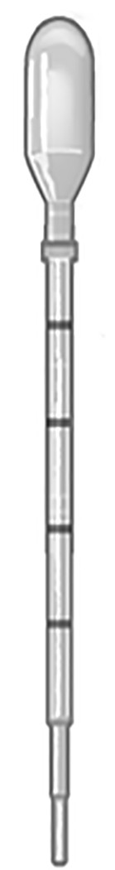
- Option 2: If using a precision pipette, transfer 0.6 mL plasma or serum from the collection tube into the sample chamber of the cartridge (see Figure 2).

Note Do not remove the thin plastic film that covers the inner ring of 13 ports of the cartridge.

Fill specimen to the 4th mark or just above with plasma or serum.

Figure 1. Xpert HBV VL Test Transfer Pipette
- Close the cartridge lid. Ensure the lid snaps firmly into place.

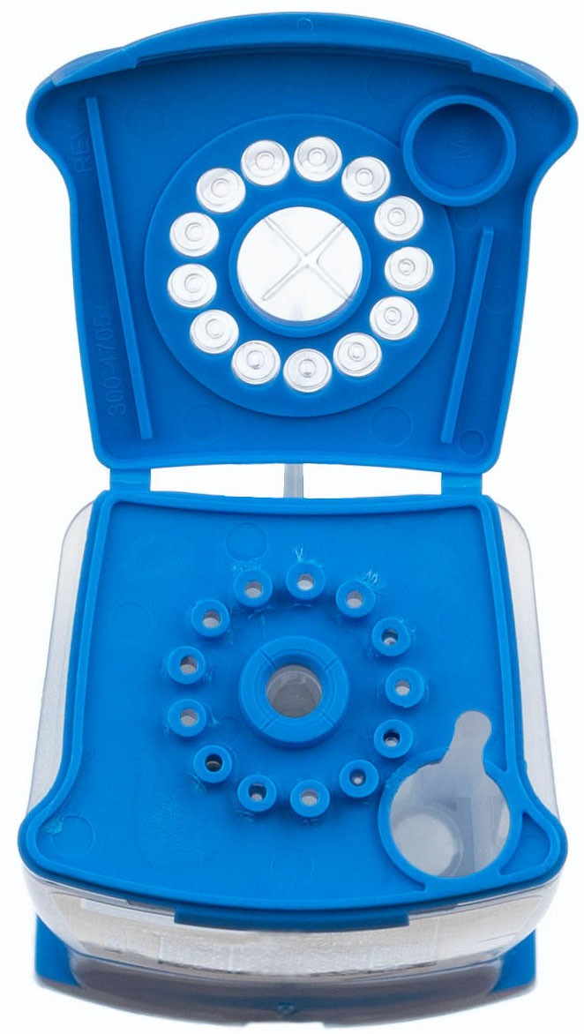
Sample Chamber (Large Opening)

Figure 2. Xpert HBV VL Cartridge (Top View)

Running the Test
- For the GeneXpert Dx System, see Section 12.3.1.
- For the GeneXpert Infinity System, see Section 12.3.2.

GeneXpert Dx System
Starting the Test

Before you start the test, make sure that:
Important ● The system is running the correct GeneXpert Dx software version shown in section - Materials Required but Not Provided.
      - The correct assay definition file is imported into the software.

This section lists the basic steps for running the test. For detailed instructions, see the GeneXpert Dx System Operator Manual.

Note The steps you follow can be different if the system administrator changed the default workflow of the system.

- Turn on the GeneXpert Dx System, then turn on the computer and log on. The GeneXpert software will launch automatically. If it does not, double-click the GeneXpert Dx software shortcut icon on the Windows® desktop.
- Log on using your username and password.
- In the GeneXpert System window, click Create Test.
The Create Test window displays. The Scan Patient ID barcode dialog box displays.
- Scan or type in the Patient ID. If typing the Patient ID, make sure the Patient ID is typed correctly.
The Patient ID is associated with the test results and displays in the View Results window and all the reports. The
Scan Sample ID barcode dialog box displays.
- Scan or type in the Sample ID. If typing the Sample ID, make sure the Sample ID is typed correctly.
The Sample ID is associated with the test results and displays in the View Results window and all the reports. The
Scan Cartridge Barcode dialog box displays.
- Scan the barcode on the cartridge. Using the barcode information, the software automatically fills the boxes for the following fields: Select Assay, Reagent Lot ID, Cartridge SN, and Expiration Date.

If the barcode on the cartridge does not scan, then repeat the test with a new cartridge. If you have scanned the
Note cartridge barcode in the software and the assay definition file is not available, a screen displays indicating the assay definition file is not loaded on the system. If this screen displays, contact Cepheid Technical Support.

- Click Start Test. In the dialog box that displays, type your password, if required.
- Open the instrument module door with the blinking green light and load the cartridge.
- Close the door. The test starts and the green light stops blinking. When the test is finished, the light turns off.
- Wait until the system releases the door lock before opening the module door, then remove the cartridge.
- Dispose of the used cartridges in the appropriate specimen waste containers according to your institution's standard practices.

Viewing and Printing Results
This section lists the basic steps for viewing and printing results. For more detailed instructions on how to view and print the results, see the GeneXpert Dx System Operator Manual.
- Click the View Results icon to view results.
- Upon completion of the test, click the Report button of the View Results window to view and/or generate a PDF report file.

GeneXpert Infinity System
Starting the Test

Before you start the test, make sure that:
Important ● The system is running the correct Xpertise software version shown in section - Materials Required but Not Provided.
      - The correct assay definition file is imported into the software.

This section lists the basic steps for running the test. For detailed instructions, see the GeneXpert Infinity System Operator Manual.

Note The steps you follow can be different if the system administrator changed the default workflow of the system.

- Power up the instrument. The Xpertise software will launch automatically. If it does not, double-click the Xpertise software shortcut icon on the Windows® desktop.
- Log on to the computer, then log on to the GeneXpert Xpertise software using your user name and password.
- In the Xpertise Software Home workspace, click Orders and in the Orders workspace, click Order Test. The Order Test - Patient ID workspace displays.
- Scan or type in the Patient ID. If typing the Patient ID, make sure the Patient ID is typed correctly.
The Patient ID is associated with the test results and displays in the View Results window and all the reports.
- Enter any additional information required by your institution, and click the CONTINUE button. The Order Test - Sample ID workspace displays.
- Scan or type in the Sample ID. If typing the Sample ID, make sure the Sample ID is typed correctly.
The Sample ID is associated with the test results and displays in the View Results window and all the reports.
- Click the CONTINUE button.
The Order Test - Assay workspace displays.
- Scan the barcode on the cartridge. Using the barcode information, the software automatically fills the boxes for the following fields: Select Assay, Reagent Lot ID, Cartridge SN, and Expiration Date.

If the barcode on the cartridge does not scan, then repeat the test with a new cartridge. If you have scanned the
Note cartridge barcode in the software and the assay definition file is not available, a screen displays indicating the assay definition file is not loaded on the system. If this screen displays, contact Cepheid Technical Support.

After the cartridge is scanned, the Order Test - Test Information workspace displays.
- Verify that the information is correct, and click Submit. In the dialog box that displays, type your password, if required.
- Place the cartridge on the conveyor belt.
The cartridge automatically loads, the test runs, and the used cartridge are placed into the waste container.

Viewing and Printing Results
This section lists the basic steps for viewing and printing results. For more detailed instructions on how to view and print the results, see the GeneXpert Infinity System Operator Manual.
- In the Xpertise Software Home workspace, click the RESULTS icon. The Results menu displays.
- In the Results menu, select the VIEW RESULTS button. The View Results workspace displays showing the test results.
- Click the REPORT button to view and/or generate a PDF report file.

Quality Control
Each test includes a Sample Volume Adequacy (SVA), Internal Quantitative Standard High and Low (IQS-H and IQS-L), Lot Specific Parameters (LSP) and a Probe Check Control (PCC).
- Sample Volume Adequacy (SVA) – Ensures the sample has been correctly added to the cartridge. The SVA verifies that the correct volume of sample has been added in the sample chamber. The SVA passes if it meets the validated acceptance criteria. If the SVA does not pass, either Error 2096 will be displayed if no sample has been added to the cartridge or ERROR 2097 if an insufficient quantity of sample has been added to the cartridge. The system will prevent the user from resuming the test.
- Internal Quantitative Standard High and Low (IQS-H and IQS-L) – IQS-H and IQS-L are two linearized plasmids with a sequence unrelated to HBV that are included in each cartridge and go through the entire test process. These are standards used to calculate the HBV DNA concentration in the sample. In addition, the IQS-H and IQS-L detect sample- associated inhibition of the real-time PCR assay, thereby acting as sample processing controls. IQS-H and IQS-L pass if they meet the validated acceptance criteria.
- Lot Specific Parameters (LSP) for Quantification – Each kit lot has built-in LSP generated from an HBV calibration panel, traceable to the 4th WHO International Standard for HBV (NIBSC code: 10/266)4, and the IQS-H and IQS-L. The LSP are unique for the reagent lot and are used to ensure correct quantification.
- Probe Check Control (PCC) – Before the start of the PCR reaction, the GeneXpert Instrument System measures the fluorescence signal from the probes to monitor bead rehydration, reaction tube filling, probe integrity and dye stability. The PCC passes if the fluorescence signals meet the validated acceptance criteria.
- External Controls – Following good laboratory practice, external controls, not provided in the kit, should be used in accordance with the requirements of local and state accrediting organizations, as applicable.

Interpretation of Results
The results are interpreted automatically by the GeneXpert Instrument System from measured fluorescent signals and embedded calculation algorithms, and are shown in the View Results window (see Figure 3 through Figure 8). The possible results are shown in Table 1.

Table 1. Xpert HBV VL Test Results and Interpretation
Note

Result | Interpretation
HBV DETECTED IU/mL  (log X.XX)  See Figure 3. | The HBV DNA is detected at XX IU/mL (log X.XX).  - The HBV DNA has a titer within the quantitative range of the test (10-1.00E09 IU/mL.  - IQS-H and IQS- L: PASS.  - Probe Check – PASS; all probe check results pass.
HBV DETECTED  >1.00E09 IU/mL  See Figure 4. | The HBV DNA is detected above the quantitative range of the test.  - IQS-H and IQS- L: PASS.  - Probe Check – PASS; all probe check results pass.
HBV DETECTED <10  IU/mL  See Figure 5. | The HBV DNA is detected below the quantitative range of the test.  - IQS-H and IQS- L: PASS.  - Probe Check – PASS; all probe check results pass.
HBV NOT DETECTED  See Figure 6. | HBV DNA is not detected.  - IQS-H and IQS- L: PASS.  - Probe Check – PASS; all probe check results pass.
INVALID  See Figure 7. | Presence or absence of the HBV DNA cannot be determined. Repeat test according to the instructions in Section 15.2. Retest Procedure.  - IQS-H and/or IQS- L: FAIL; Cycle threshold (Ct) values are not within the valid range.  - Probe Check – PASS; all probe check results pass.
ERROR  See Figure 8. | Presence or absence of the HBV DNA cannot be determined. Repeat test according to the instructions in Section 15.2. Retest Procedure.  - Probe Check – FAIL *; all or one of the probe check results fail.  * If the probe check passed, the error is caused by the maximum pressure limit exceeding the valid range or by a system component failure.
NO RESULT | Presence or absence of HBV DNA cannot be determined. Repeat test according to the instructions in Section 15.2. Retest Procedure. A NO RESULT indicates that insufficient data were collected. For example, the operator stopped a test that was in progress.

Test screenshots are for example only. The version number may vary from the screenshots shown in these instructions for use.

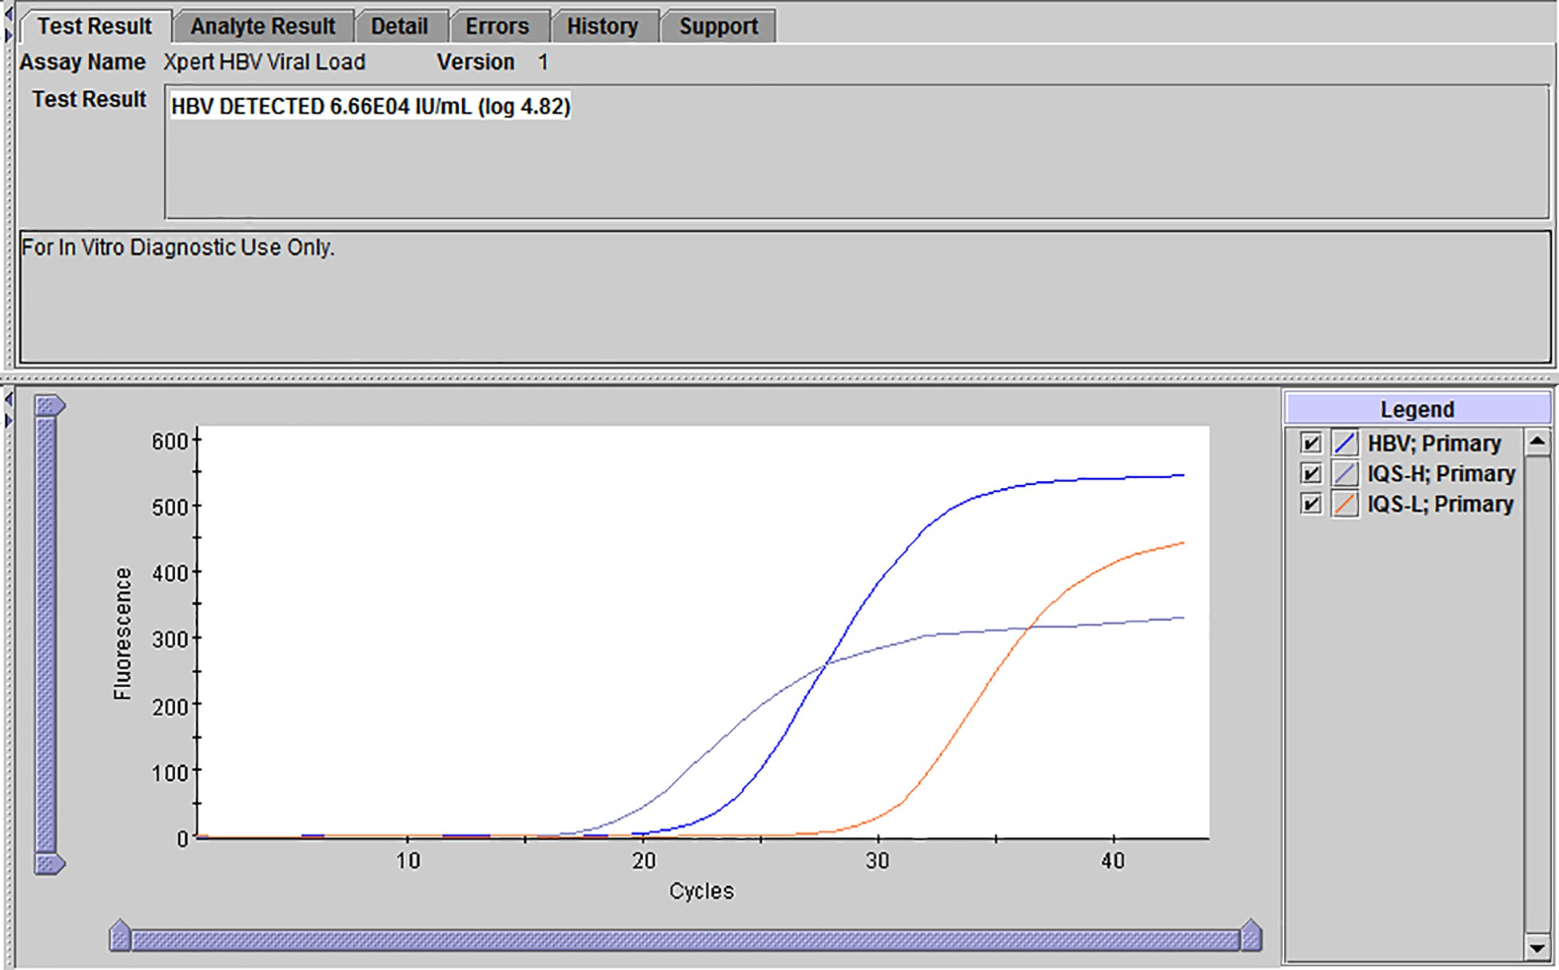

Figure 3. Result: HBV Detected and Quantified
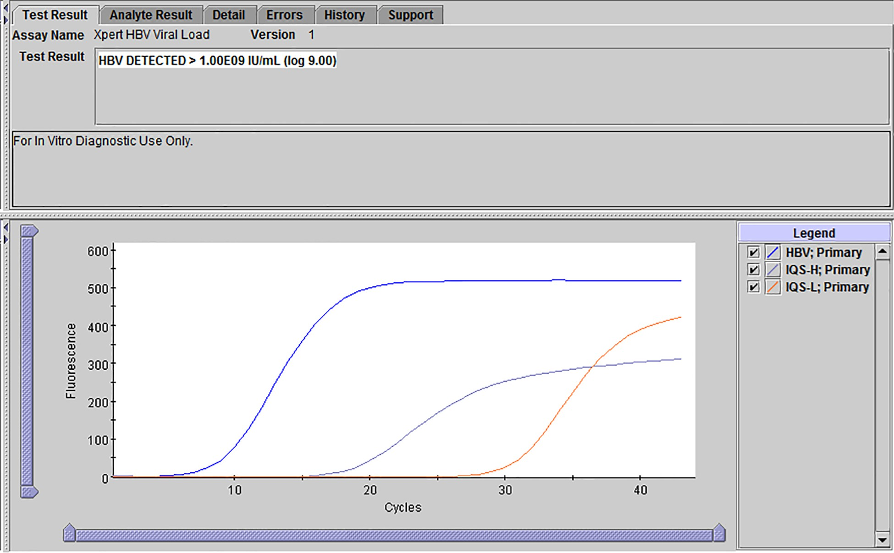

Figure 4. Result: HBV Detected but with Titer Above the Quantitative Range of the Test

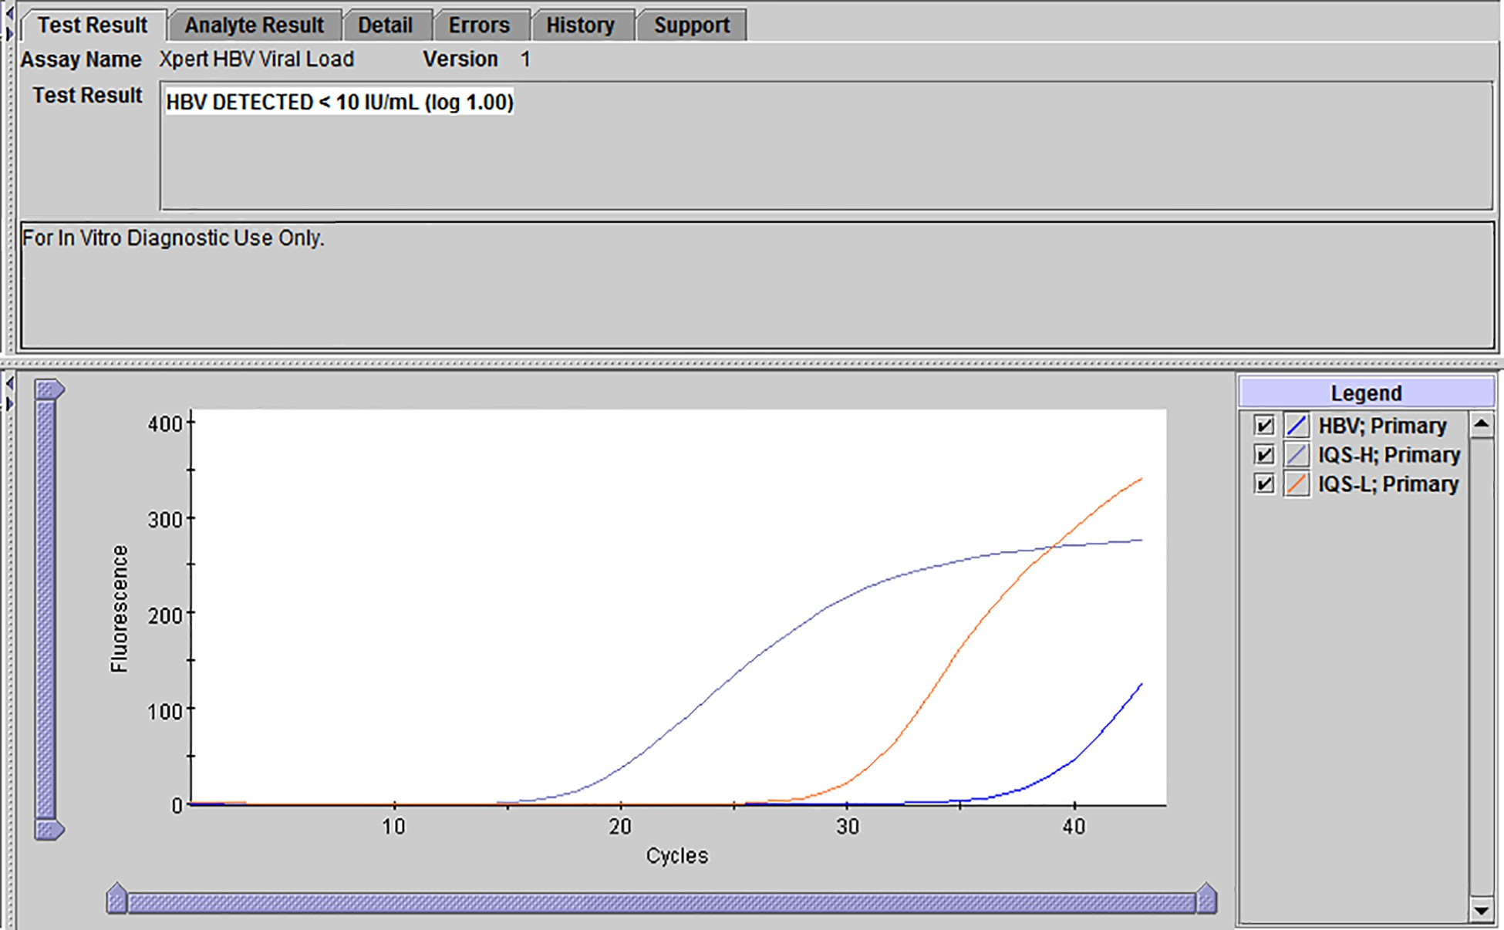

Figure 5. Result: HBV Detected but with Titer Below the Quantitative Range of the Test
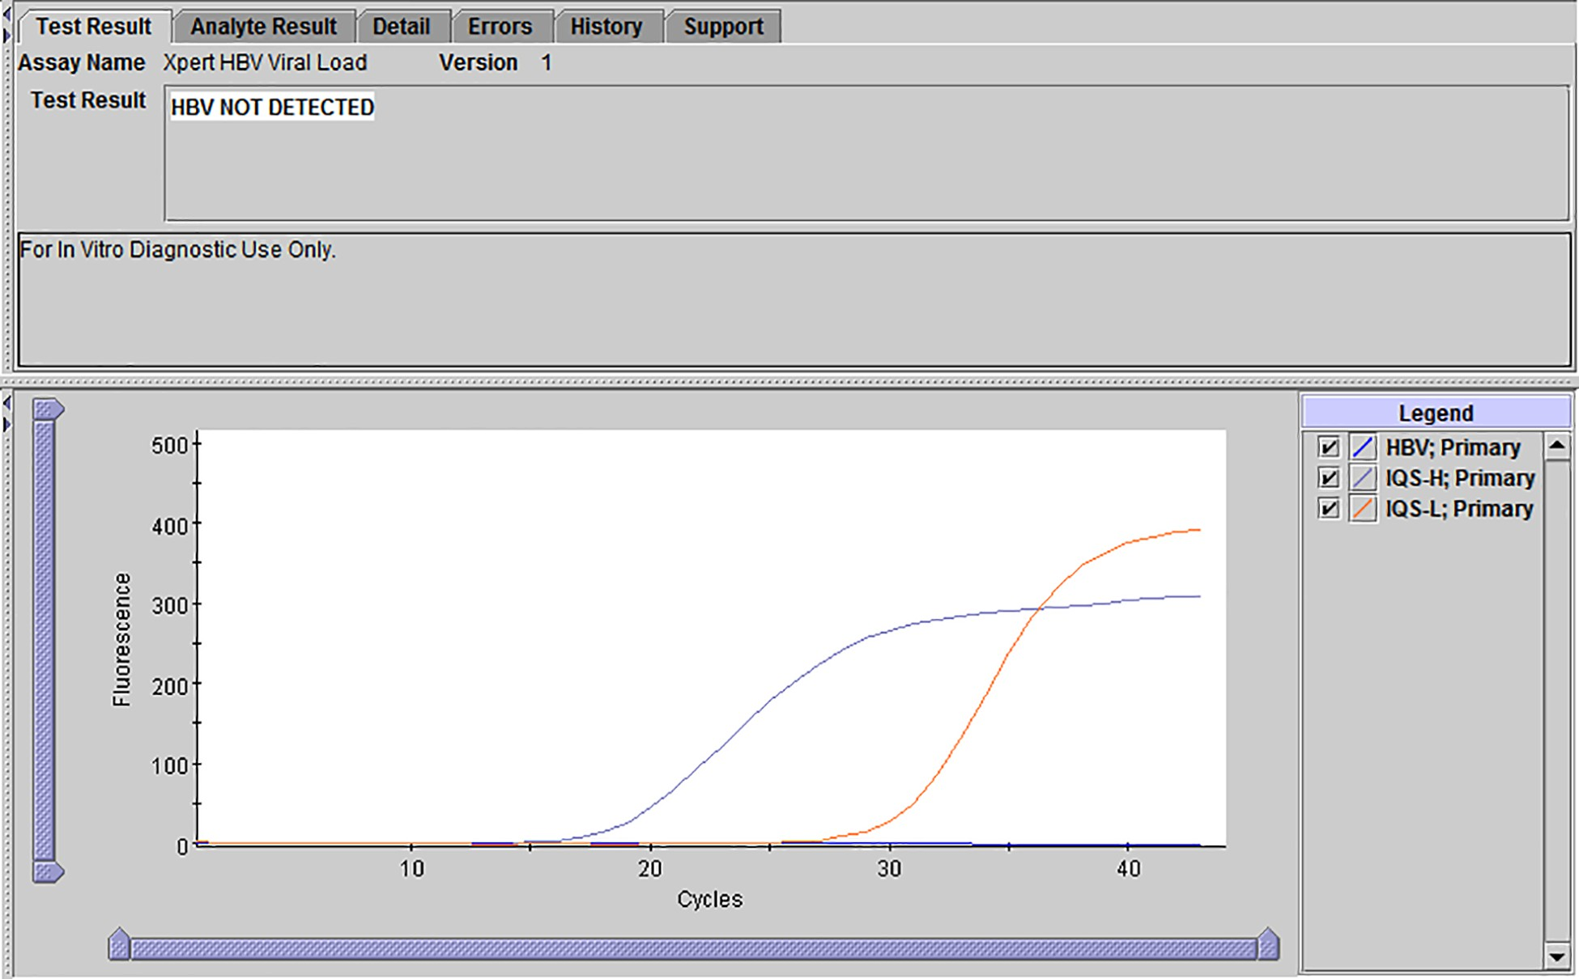

Figure 6. Result: HBV Not Detected

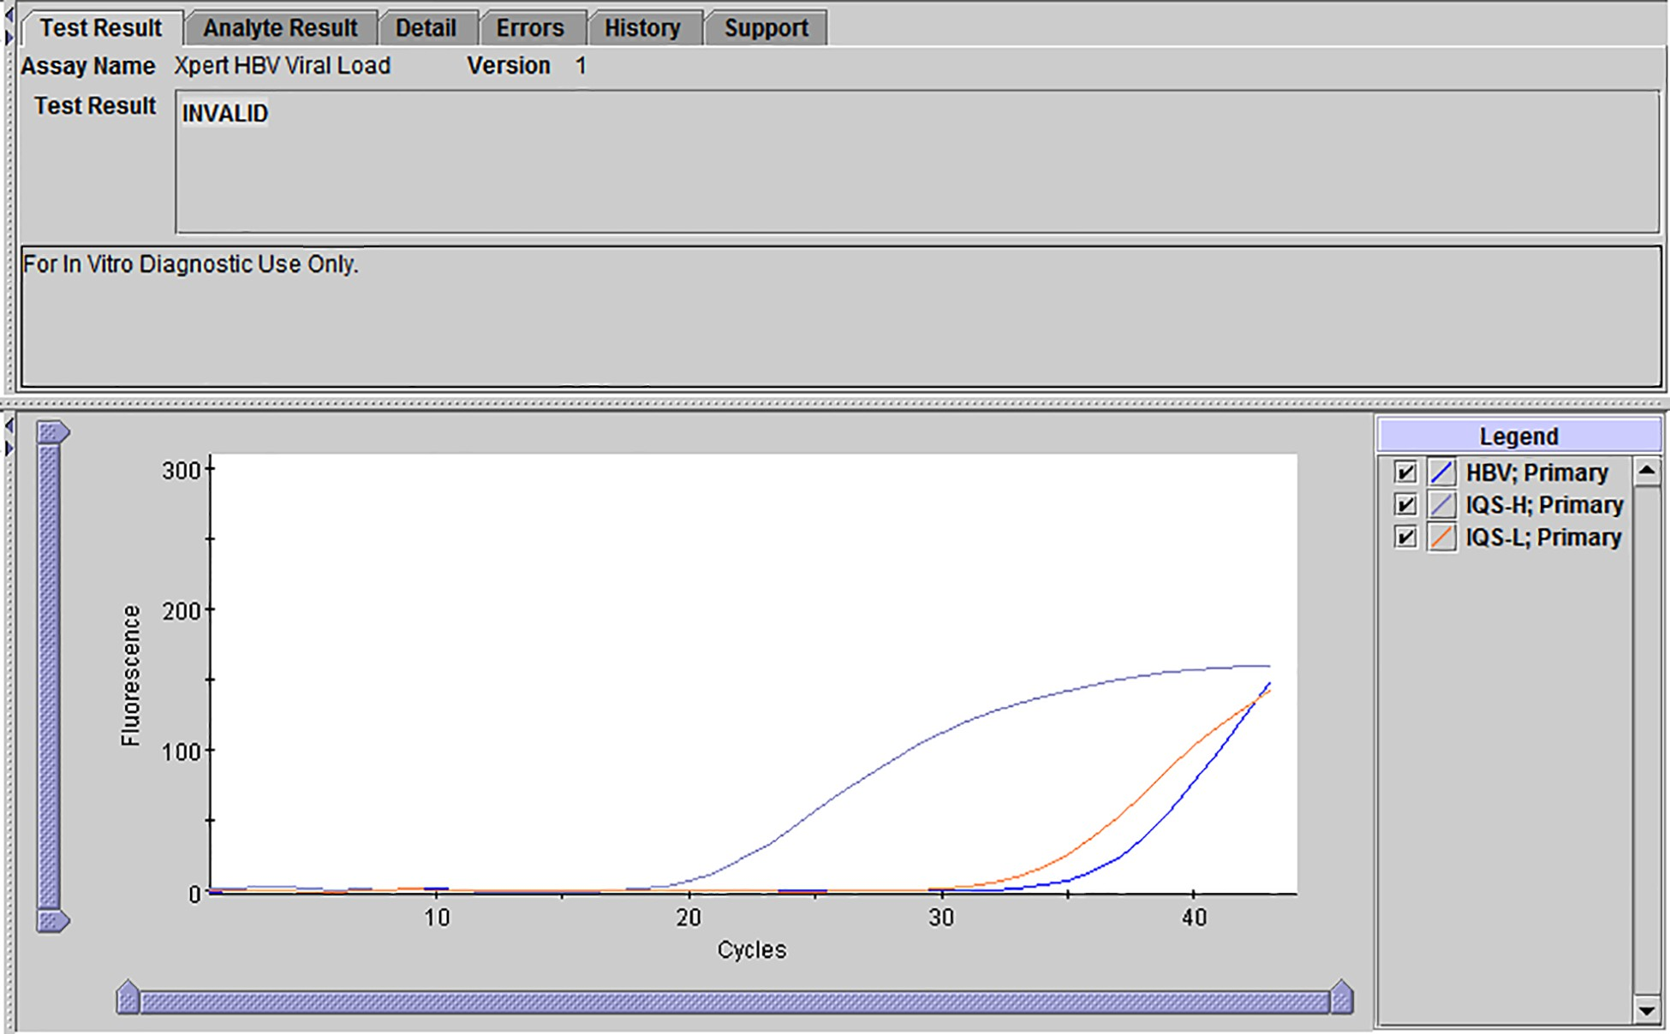

Figure 7. Result: Invalid Result
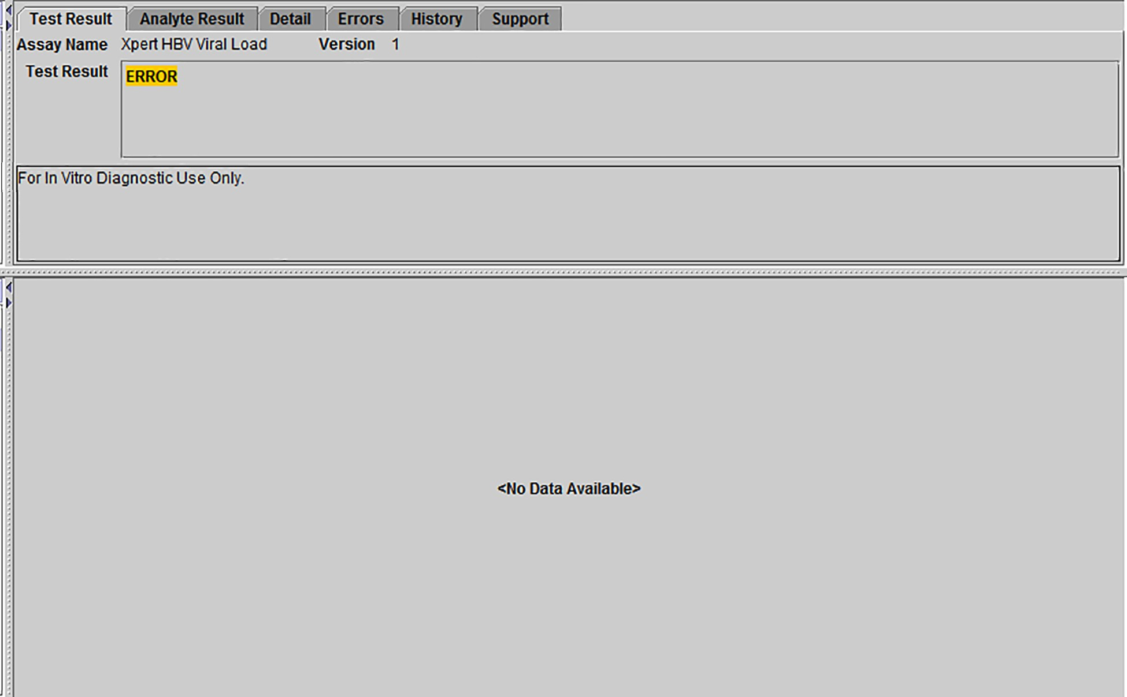

Figure 8. Result: Error

Retests

Reasons to Repeat the Test
If any of the test results mentioned below occur, repeat the test according to instructions in the Section 15.2. Retest Procedure.
- An INVALID result indicates one or more of the following:
  - The IQS-H and/or IQS-L Ct values are not within the valid range.
  - The sample was not properly processed or PCR was inhibited.
- An ERROR result indicates that the test was aborted. Possible causes include: insufficient volume of sample was added, the reaction tube was filled improperly, a reagent probe integrity problem was detected, or the maximum pressure limit was exceeded.
- A NO RESULT indicates that insufficient data were collected. For example, the operator stopped a test that was in progress or a power failure occurred.

Retest Procedure
If the result of a test is either INVALID, ERROR, or NO RESULT, use a new cartridge to retest the affected specimen (do not reuse the cartridge).
- Remove a new cartridge from the kit.
- Follow the procedures in Section 12. Procedure, including Section 12.2. Preparing the Cartridge and Starting the Test.
- If a sample yields a second INVALID result upon retesting, continued retesting is not recommended.

Limitations and Contraindications
- Good laboratory practices and changing gloves between the handling of specimens are recommended to avoid contamination of specimens or reagents.
- Rare mutations within the target region of the Xpert HBV VL test may affect primer or probe binding resulting in under- quantitation or failure to detect the virus.
- This test has been validated only for HBV genotypes A-H. Testing of other genotypes which may have different sequences within the region targeted by the Xpert HBV VL test may affect the primer or probe binding resulting in under-quantitation or failure to detect the virus.
- This test has been validated only for use with serum and K₂ EDTA and PPT-EDTA plasma. Testing of other sample types may result in inaccurate results.
- A negative test result does not preclude HBV infection. Therefore, the Xpert HBV VL test should not be used as a diagnostic test to confirm the presence of HBV infection.
- Processing pooled specimens may cause false results.

Metrological Traceability

Calibration and Traceability to the 4th WHO International Standard for HBV DNA for NAT
The calibration of the Xpert HBV VL test is traced to the 4th WHO International Standard for HBV for NAT (NIBSC code 10/266)4 (4th WHO IS). The calibration is built into the final product and no calibration is performed by the end user. Each kit lot of the Xpert HBV VL test has a set of lot specific quantitation parameters (slope and intercept) integrated into the test cartridge barcode. Included in each cartridge are also the Internal Quantitative Standards (IQS) High and Low with DNA sequences unrelated to HBV, which are used together with the quantitation parameters to calculate the HBV DNA concentration in a routine or patient sample.
The lot specific quantitation parameters are determined through testing of the Cepheid HBV Calibration Panel using the Xpert HBV VL test each time a new test lot is manufactured. The panel consists of heat inactivated HBV that is 10-fold diluted in serum to six concentrations. Each dilution level of the Cepheid HBV Calibration Panel is tested with multiple replicates and repeated twice for increased precision.

Each lot of Cepheid HBV Calibration Panel is assigned a value in a calibration transfer protocol where the Cepheid HBV Secondary Standard is the higher order calibrator. The Cepheid HBV Secondary Standard is 10-fold diluted to four levels and both calibrators are measured with the Xpert HBV VL test. The protocol includes multiple replicates and three replicate dilution and measuring procedures. The results from the three replicate procedures are pooled together to form a standard curve for each calibrator. The Cepheid HBV Secondary Standard is in turn value assigned to the primary 4th WHO International Standard.
Pooled standard curves of the primary 4th WHO International Standard, the Cepheid HBV Secondary Standard and the Cepheid HBV Calibration Panel are shown in Figure 9. The Xpert HBV VL test calibration process shows co-linear performance and gives quantitation values for Cepheid HBV Calibrators and the 4th WHO International Standard that are similar to the expected values.
The combined standard measurement uncertainty was evaluated for the Cepheid calibrators and was estimated to 0.05 Log IU/mL for the Secondary Standard and 0.12 Log IU/mL for the Calibration Panel.

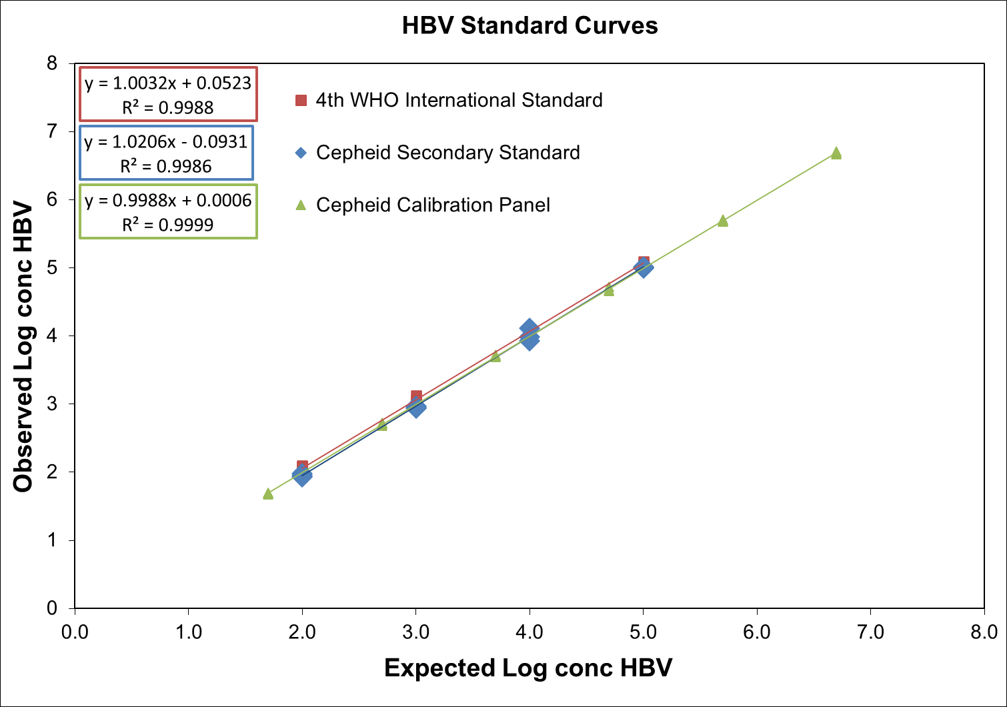
Figure 9. Standard curves of the primary 4th WHO international standard (red), the Cepheid HBV Secondary Standard (blue) and the Cepheid HBV Calibration Panel (green). The expected Log Conc HBV values are the nominal titer values derived from the 4th WHO
IS value. The observed Log Conc HBV values are the result from the Xpert HBV VL test.

Analytical Performance

Analytical Sensitivity (Limit of Detection (LOD)) and Analytical Reactivity/ Inclusivity

Genotype A
The limit of detection (LOD) of the Xpert HBV VL test was determined for HBV genotype A by testing serial dilutions of the 4th WHO IS for HBV DNA for NAT (NIBSC code 10/266)4 diluted in HBV-negative EDTA plasma and serum. Panels of six concentration levels and a negative were tested using either four or three reagent lots for EDTA plasma and serum panels, respectively. Each panel member was tested across three days with 24 replicates per reagent lot. In total 96 replicates per plasma panel member and 72 replicates per serum panel member were tested.
The results for EDTA plasma and serum are shown in Table 2.

Table 2. Limit of Detection (Genotype A) for the Xpert HBV VL Test using the 4th WHO IS for HBV DNA for NAT

Genotype | Matrix | Nominal HBV Concentration (IU/mL) | Number of Valid  Replicates | Number of Positives | Positivity Rate (%) | 95% LOD by PROBIT  (95% Confidence Interval)
 |  | 10 | 95 | 95 | 100
 |  | 5 | 96 | 94 | 98
A | Plasma | 2.5 | 96 | 82 | 85 | 3.20 IU/mL
 |  | 1.25 | 96 | 62 | 65 | (2.79 – 3.60 IU/mL)
 |  | 0.625 | 96 | 41 | 43
 |  | 0 | 96 | 0 | 0
 |  | 10 | 72 | 70 | 97
 |  | 5 | 72 | 63 | 88
A | Serum | 2.5 | 72 | 58 | 81 | 5.99 IU/mL
 |  | 1.25 | 72 | 37 | 51 | (5.13 – 6.86 IU/mL)
 |  | 0.625 | 71 | 15 | 21
 |  | 0 | 72 | 0 | 0
The study demonstrated that the Xpert HBV VL test detected HBV DNA for the 4th WHO IS at a concentration of 3.20 IU/ mL in EDTA plasma and a concentration of 5.99 IU/mL in serum with a positivity rate of 95% as determined by PROBIT regression.

Genotypes B-H in EDTA Plasma
The LOD for HBV genotypes B through H was determined by testing six- or seven-member panels prepared by spiking HBV positive specimens representing each genotype (genotypes B through G from the WHO International Reference Panel, PEI code: 5086/08, and a genotype H clinical specimen) into HBV-negative EDTA plasma. Each panel member was tested over three days using three reagent lots for a total of 24 replicates per member.
The study demonstrated that the LOD for HBV genotypes B through H in EDTA plasma are as follows:

Table 3. LOD for Genotypes B-H in EDTA Plasma

Genotype | 95% LOD by PROBIT (IU/mL) | 95% Confidence Interval (IU/mL)
B | 1.34 | 0.98 – 1.69
C | 1.63 | 1.23 – 2.03
D | 3.96 | 3.01 – 4.92
E | 3.77 | 2.76 – 4.78
F | 2.39 | 1.82 – 2.96
G | 1.21 | 0.95 – 1.47
H | 3.84 | 2.91 – 4.77

Genotypes B-H in Serum
The LOD for HBV genotypes B through H was verified in serum in accordance with CLSI EP17-A210 using 24 replicates. A higher concentration was tested if a positivity rate of > 85% was not achieved. See Table 4 for results.
The study demonstrated that the LOD for HBV genotypes B through H in serum are as follows:

Table 4. Verification of LOD for Genotypes B through H in Serum

Genotype | Nominal HBV Concentration (IU/mL) | Positivity Rate (%)
B | 1.34 | 88
C | 3.25 | 96
D | 3.96 | 96
E | 3.77 | 96
F | 2.39 | 92
G | 1.21 | 88
H | 3.84 | 100

Precore Mutants
The performance of the Xpert HBV VL test was also evaluated with a precore mutant by testing a sequenced HBV clinical specimen including the two precore mutations (C1858T and G1896A) and the two basal core promoter mutations (A1762T and G1764A), diluted to a concentration of 10 IU/mL in EDTA plasma and serum with one reagent lot. A positivity rate of 100% was achieved for each of the 24 replicates tested in each matrix.

Lower Limit of Quantitation (LLOQ)
The lower limit of quantitation (LLOQ) is defined as the lowest concentration of HBV DNA that is quantified with acceptable precision and trueness and is determined using the total analytical error (TAE) and an approach based upon the difference between two measurements. The LLOQ was evaluated with four independent samples, representing HBV
genotypes A through D, in EDTA plasma near the test limit of detection. Each sample was tested using four reagent lots with 8-24 replicates per lot. TAE was estimated with the Westgard model according to the CLSI guideline EP17-A210 with the criterion, [(Absolute Bias) + 2 SDs ≤ 1 log₁₀ IU/mL]. The difference between two measurements approach was evaluated with the criterion, [(2 x SQRT(2) x SD) ≤ 1 log₁₀ IU/mL].
The LLoQ analyses for each sample are presented in Table 5. The results demonstrate that the HBV-VL test can quantify 10 IU/mL of HBV DNA with an acceptable trueness and precision.

Table 5. Determination of the LLOQ for the Xpert HBV VL Test

HBV  Genotype | Lot | N | HBV Concentration (log10 IU/mL) |  | Bias | Total SD | Total Analytical Errora | Two Measurement Approachb
 |  |  | Expected | Observed
A | 1 | 24 | 1.00 | 1.02 | 0.02 | 0.20 | 0.42 | 0.57
 | 2 | 24 | 1.00 | 1.05 | 0.05 | 0.16 | 0.37 | 0.45
 | 3 | 24 | 1.00 | 0.94 | -0.06 | 0.20 | 0.46 | 0.57
 | 4 | 23 | 1.00 | 1.02 | 0.02 | 0.14 | 0.30 | 0.40
B | 1 | 16 | 1.00 | 1.18 | 0.18 | 0.11 | 0.39 | 0.30
 | 2 | 24 | 1.00 | 1.18 | 0.18 | 0.17 | 0.53 | 0.49
 | 3 | 8 | 1.00 | 1.17 | 0.17 | 0.19 | 0.54 | 0.53
 | 4 | 8 | 1.00 | 1.25 | 0.25 | 0.19 | 0.64 | 0.55
C | 1 | 16 | 1.00 | 1.10 | 0.10 | 0.17 | 0.44 | 0.47
 | 2 | 24 | 1.00 | 1.11 | 0.11 | 0.22 | 0.55 | 0.61
 | 3 | 8 | 1.00 | 0.83 | -0.17 | 0.24 | 0.65 | 0.68
 | 4 | 8 | 1.00 | 1.01 | 0.01 | 0.18 | 0.36 | 0.50
D | 1 | 16 | 1.00 | 0.81 | -0.19 | 0.28 | 0.74 | 0.78

HBV  Genotype | Lot | N | HBV Concentration (log10 IU/mL) |  | Bias | Total SD | Total Analytical Errora | Two Measurement Approachb
 |  |  | Expected | Observed
 | 2 | 24 | 1.00 | 0.79 | -0.21 | 0.27 | 0.75 | 0.76
 | 3 | 8 | 1.00 | 0.83 | -0.14 | 0.14 | 0.42 | 0.39
 | 4 | 8 | 1.00 | 0.91 | -0.09 | 0.11 | 0.31 | 0.32

a TAE calculated according to the Westgard model where [TAE = | Bias | + (2×SD) ≤ 1 log₁₀ IU/mL] ensuring there is a 95% probability that the measurement will be less than 1 log₁₀ IU/mL from the true value.
b Two measurements approach [2 × (SQRT(2) × SD) ≤ 1 log₁₀ IU/mL] indicates that a difference of less than 1 log₁₀ IU/mL can be explained by a random measurement error.
The results demonstrate that the Xpert HBV VL test can quantify 10 IU/mL of HBV DNA with an acceptable trueness and precision.

Precision and Reproducibility
The precision/reproducibility of the Xpert HBV VL test was evaluated in K₂EDTA plasma using an analysis of variance (ANOVA) to estimate total variance.
This study was a multi-center (3 sites; 2 external and 1 internal) blinded study to estimate the major components of variance of the Xpert HBV VL test using an eight-member panel consisting of eight HBV positive members. The HBV positive members were prepared by diluting either a well characterized HBV plasmid or an HBV positive clinical specimen into human EDTA plasma. Two operators, one with prior PCR experience and one without, at each of the three study sites, tested one panel in duplicate, two times per day (equivalent to eight replicates per day) over six testing days for a total of 144 replicates per panel member. Three lots of the Xpert HBV VL test were used, with each lot representing two days of testing. Precision and reproducibility were evaluated in accordance with CLSI EP05-A311 and CLSI EP15-A3.12
The precision and reproducibility of the Xpert HBV VL test was evaluated by using nested ANOVA with terms for Site/ Instrument, Lot, Day, Operator/Run and Within-Run. The standard deviation and the percentage of variability due to each component of the log₁₀ HBV transformed concentrations were calculated as shown in Table 6.

Table 6. Precision/Reproducibility of the Xpert HBV VL Test

HBV DNA Concentration (Log10IU/mL) |  |  | Contribution to Total Variance SD (CV%) |  |  |  |  |  |  |  |  |  | Total Precision
 |  |  | Site/ Instrument |  | Lot |  | Day |  | Operator/Run |  | Within-run
Expected | Observed | N | SD | (%)a | SD | (%) a | SD | (%) a | SD | (%) a | SD | (%) a | SD | CV (%)b
9.00 | 9.13c | 144 | <0.01 | <0.01 | 0.04 | 23.4 | <0.01 | <0.01 | 0.02 | 4.9 | 0.07 | 71.7 | 0.08 | 19.7
8.00 | 8.17 | 144 | <0.01 | <0.01 | 0.04 | 26.7 | <0.01 | <0.01 | 0.02 | 5.4 | 0.06 | 67.9 | 0.07 | 16.9
7.00 | 7.15 | 144 | 0.01 | 2.2 | 0.03 | 12.2 | 0.01 | 3.9 | <0.01 | <0.01 | 0.07 | 81.8 | 0.07 | 16.8
6.00 | 6.18 | 144 | <0.01 | <0.01 | 0.04 | 32.1 | 0.01 | 4.3 | <0.01 | <0.01 | 0.05 | 63.6 | 0.06 | 14.7
4.70 | 4.87 | 144 | 0.02 | 4.5 | 0.03 | 15.3 | <0.01 | <0.01 | <0.01 | <0.01 | 0.07 | 80.2 | 0.07 | 17.1
3.00 | 3.19 | 144 | <0.01 | <0.01 | 0.03 | 28.8 | <0.01 | <0.01 | 0.02 | 11.5 | 0.04 | 59.7 | 0.06 | 13.2
2.00 | 2.17 | 144 | <0.01 | <0.01 | 0.02 | 8.6 | <0.01 | <0.01 | 0.01 | 1.0 | 0.08 | 90.5 | 0.08 | 19.0
1.00 | 1.13 | 144 | <0.01 | <0.01 | <0.01 | <0.01 | 0.05 | 11.0 | 0.01 | 0.3 | 0.15 | 88.8 | 0.16 | 37.7
a (%) is contribution of variance component to overall variance
b

“CV” is lognormal CV, as obtained using the formula:
c Observed value is above the quantitative range of the Xpert HBV VL test.

The precision analysis showed that the total variance is below the acceptance criteria of 0.1 Log₁₀ IU/mL for the higher concentrations, below 0.15 Log₁₀ IU/mL for the middle concentrations and below 0.3 Log₁₀ IU/mL for the lowest concentration.

Linear Range

Genotype A
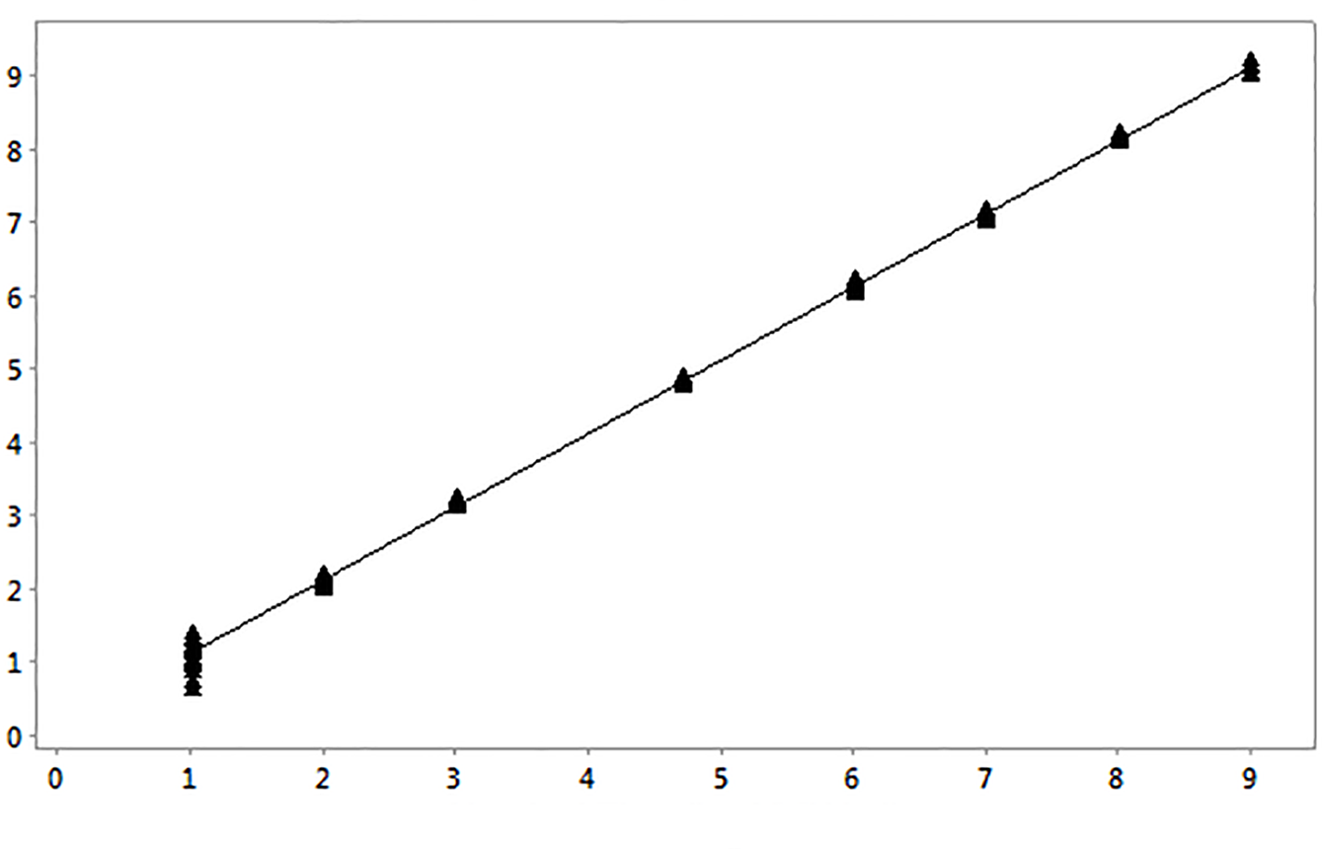
The linear range of the Xpert HBV VL test was determined by analysis of an eight member panel covering an HBV concentration range from 1.00 – 9.00 log₁₀ IU/mL. Panels were prepared by spiking an HBV genotype A clinical specimen or a high titer HBV plasmid DNA stock in HBV-negative EDTA plasma and serum. Each panel member was analyzed in replicates of eight per reagent lot, except for the lowest dilutions which were analyzed in replicates of sixteen per reagent lot, using two reagent lots. The results are presented in Figure 10 and Figure 11.
Linearity - Genotype A in Plasma

Nominal Titer (log10 IU/ml)

Figure 10. Linearity for the Xpert HBV VL Test in EDTA Plasma
Xpert HBV VL Assay Results (log10 IU/ml)

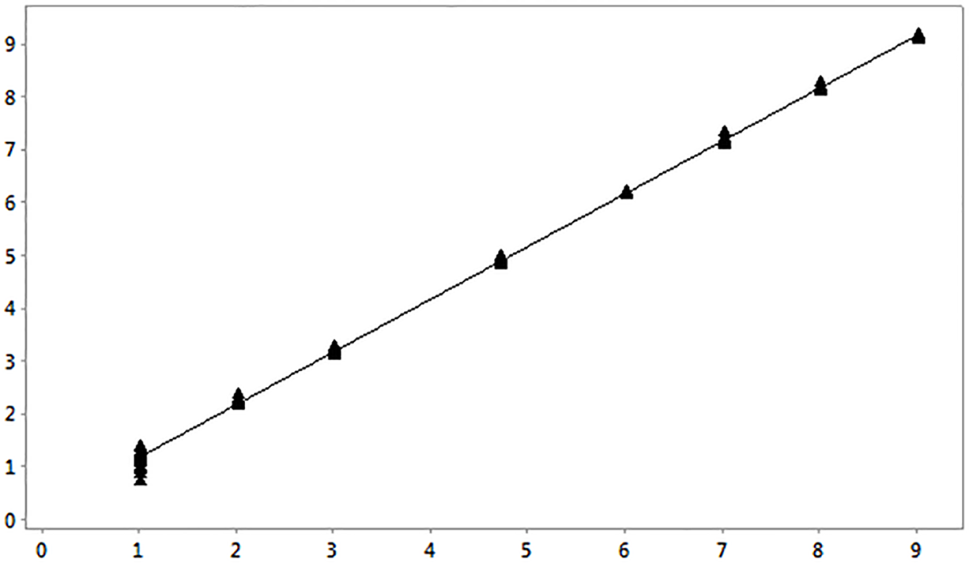
Figure 11. Linearity for the Xpert HBV VL Test in EDTA Serum
Linearity - Genotype A in Serum

Nominal Titer (log10 IU/ml)
Xpert HBV VL Assay Results (log10 IU/ml)

Genotypes B-H
To confirm the linearity, dilution panels representing HBV genotypes B to H were prepared to cover a measuring range as wide as possible by diluting a clinical specimen representing each genotype in HBV-negative EDTA plasma. Panel members were analyzed with the same number of replicates as for HBV genotype A using one reagent lot.
Linearity was demonstrated according to CLSI guideline EP06-A13 for genotype A-H with an R2 >0.99. The Xpert HBV VL test is linear across a range of 1.00 – 9.00 log₁₀ IU/mL in serum and plasma for genotype A and across the range tested for genotypes B to H (see Table 7) in plasma. Matrix equivalence was shown for genotype B to H (see Section 20) over the dynamic range and linearity for genotype B to H is therefore also valid in serum.
Table 7. Linearity of the Xpert HBV VL Test by Genotype

Genotype | Linear Regression Equation | R2 | Tested Titer Range (Log₁₀IU/mL)
A (Plasma) | y = 1.005x + 0.093 | 0.999 | 1.00 – 9.00
A (Serum) | y = 1.000x + 0.167 | 0.999 | 1.00 – 9.00
B | y = 0.998x – 0.027 | 0.995 | 1.00 – 6.83
C | y = 0.998x – 0.119 | 0.998 | 1.00 – 7.69
D | y = 0.993x + 0.101 | 0.998 | 1.00 – 7.41
E | y = 1.010x – 0.149 | 0.999 | 1.00 – 8.14
F | y = 0.994x – 0.068 | 0.999 | 1.00 – 7.96
G | y = 0.990x + 0.538 | 0.999 | 1.00 – 8.61
H | y = 0.991x + 0.122 | 0.999 | 1.00 – 6.35

Analytical Specificity (Exclusivity)
The analytical specificity of the Xpert HBV VL test was evaluated by adding potentially cross-reacting organisms at a concentration of 1 × 106 CFU/mL for microorganisms, or 1 × 105 copies/mL or TCID₅₀/mL for viruses into HBV-negative EDTA plasma and EDTA plasma containing approximately 30 IU/mL of HBV reference material (4th WHO IS4. Tested organisms are listed in Table 8. None of the tested organisms showed cross reactivity or interfered with the quantification of the Xpert HBV VL test.
Table 8. Analytical Specificity Organisms

Viruses |  | Bacteria | Yeast
BK Human polyoma virus | Human Immunodeficiency virus 1 | Staphylococcus epidermidis | Candida albicans
Cytomegalovirus | Human Immunodeficiency virus 2 | Staphylococcus aureus
Epstein-Barr virus | Human papilloma virus 16
Hepatitis A virus | Human papilloma virus 18
Hepatitis C virus | Human T-cell lymphotropic virus type 1
Herpes simplex virus 1 | Human T-cell lymphotropic virus type 2
Herpes simplex virus 2 | Varicella Zoster virus
Human herpes virus 6 | Vaccina virus
Human herpes virus 8

Potentially Interfering Substances
The susceptibility of the Xpert HBV VL test to interference by elevated levels of endogenous substances, by autoimmune disease markers, and by drugs prescribed to HBV infected patients was evaluated. The inhibitory effects were evaluated both in the presence and absence of approximately 30 IU/mL HBV DNA reference material (4th WHO IS).4

Endogenous Substances
Elevated levels of the endogenous substances listed in Table 9 were shown not to interfere with the quantification of the Xpert HBV VL test with the mean log₁₀ titer of each of the positive HBV samples containing potentially interfering
substances within ± 0.10 log₁₀ IU/mL of the positive control. Negative results were obtained for all samples without HBV target demonstrating there was no impact on the assay specificity.

Table 9. Endogenous Substances and Concentration Tested

Substance | Tested Concentration
Albumin | 9 g/dL
Bilirubin | 20 mg/dL
Hemoglobin | 500 mg/dL
Human DNA | 0.4 mg/dL
Triglycerides | 3000 mg/dL

Exogenous Substances or Drugs
The drug components as presented in Table 10 were shown to not interfere with the quantification of the Xpert HBV VL test or impact the test specificity when tested at three times peak plasma level concentration (C_{max}) in the presence and absence of HBV DNA.

Table 10. Drug Pools Tested

Pool | Drugs
1 | Zidovudine, Saquinavir, Clarithromycin, Interferon-alfa-2b, Ritonavir, Ombitasvir, Paritaprevir, Dasabuvir, Didanosine
2 | Abacavir Sulfate, Fosamprenavir, Peginterferon-alfa-2a, Ribavirin, Entecavir, Adefovir Dipivoxil
3 | Tenofovir disoproxil fumarate, Lamivudine, Indinavir sulfate, Ganciclovir, Valganciclovir HCl, Acyclovir, Paroxetine, Telbivudine
4 | Stavudine, Efavirenz, Lopinavir, Enfuvirtide, Ciprofloxacin Fluoxetin
5 | Nevirapine, Nelfinavir, Azithromycin, Valacyclovir, Sertraline, Tenofovir, Alafenamide

Autoimmune Disease Markers
Testing of K₂EDTA plasma specimens from five individuals positive for each of the autoimmune disease markers systemic lupus erythematosus (SLE), anti-nuclear antibody (ANA), or rheumatoid factor (RF) showed no interference with the performance of the Xpert HBV VL test. The mean log₁₀ concentrations of samples spiked with HBV DNA were within ±
0.10 log₁₀ IU/mL of the positive control. Negative results were obtained for all samples without HBV target demonstrating there was no impact on the assay specificity.

Carryover Contamination
A high titer HBV positive sample (>1 x 107 IU/mL) was tested, immediately followed by testing an HBV negative sample in the same GeneXpert instrument module. The procedure was repeated twenty (20) times in two modules. The carryover rate for the Xpert HBV VL test was 0%.

Whole System Failure Rate
The whole system failure rate for the Xpert HBV VL test was determined by testing 144 replicates of an HBV low positive sample at approximately 10 IU/mL consisting of K₂EDTA plasma spiked with a HBV genotype A clinical specimen calibrated to the 4th WHO International Standard for HBV (NIBSC code 10/266).
The results of this study showed that all 144 replicates were reported HBV positive, resulting in a whole system failure rate of 0%.

Matrix Equivalency (K₂EDTA Plasma, PPT-EDTA and Serum)
Matrix equivalency for the Xpert HBV VL test was conducted with 55 matched HBV positive clinical specimens and 25 matched HBV negative clinical specimens collected in K₂EDTA plasma, PPT-EDTA plasma and serum collection tubes. Out of the 55 positive samples, 32 were HBV positive clinical specimens and 23 were HBV negative clinical specimens spike with HBV positive material, from clinical specimens representing HBV genotypes B to G and a DNA plasmid expressing the HBV genotype A target sequence, with titers across the entire linear range.
Matrix equivalency was demonstrated in the tested samples as shown in Figure 12 and Figure 13.

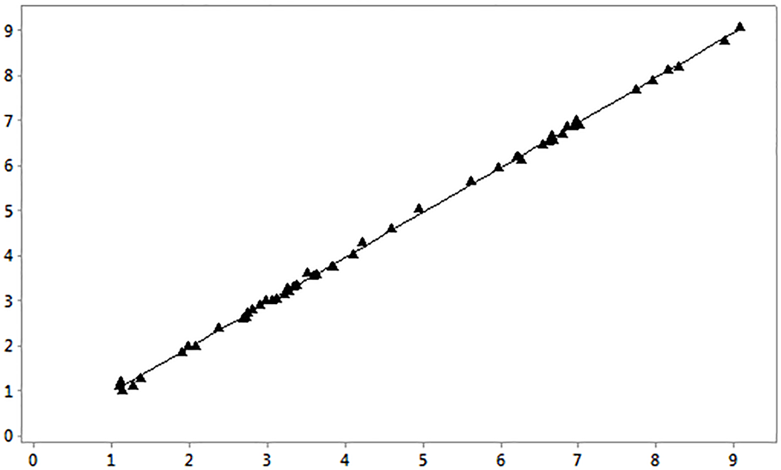
Figure 12. Linear Regression Plot of PPT-EDTA Plasma versus K₂EDTA Plasma
Matrix Equivalence, PPT vs K2EDTA plasma

K2EDTA titer(log10 IU/mL)
PPT titer (log10 IU/mL)

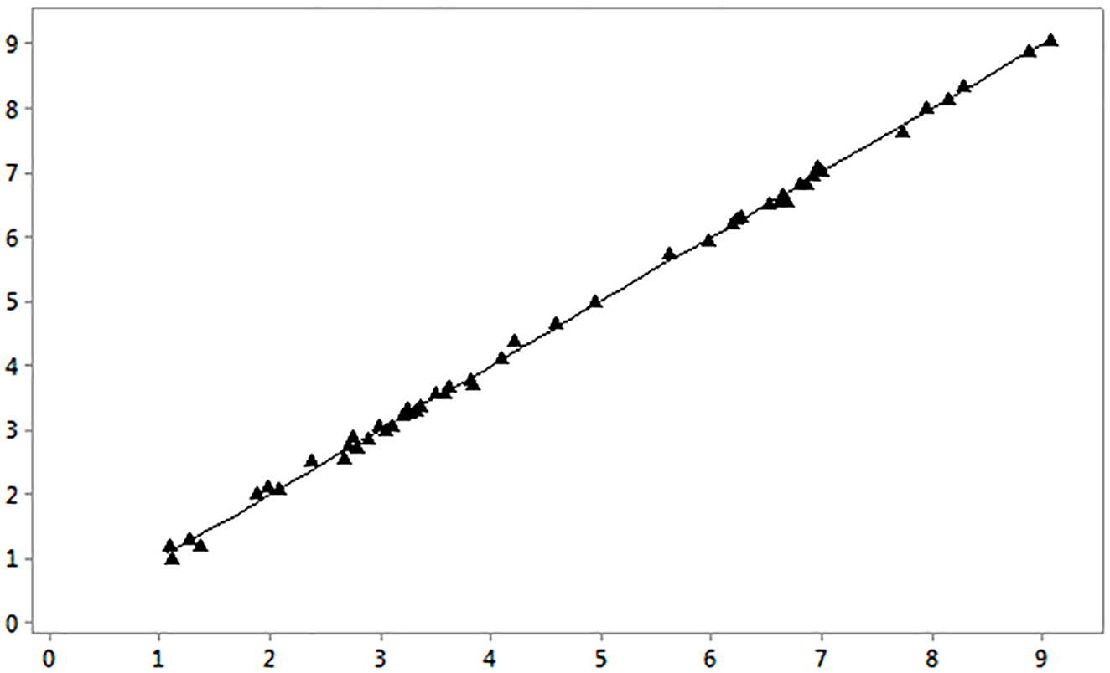
Figure 13. Linear Regression Plot of Serum versus K₂EDTA Plasma
Matrix Equivalence, Serum vs K2EDTA Plasma

K2EDTA titer (log10 IU/mL)
Serum titer (log10 IU/mL)

The results show that the Xpert HBV VL test performs equivalently in K₂-EDTA plasma, PPT-EDTA plasma and serum for specimens in the range of approximately 1.0-9.0 log10 IU/mL.

Clinical Performance

Specificity in Normal Healthy Blood Donors
The specificity of the Xpert HBV VL test was evaluated using 99 serum and 100 EDTA plasma specimens from HBV negative blood donors. The specificity of the Xpert HBV VL test was 100.0% [95% CI: 98.1-100.0 (199/199)].

Method Correlation
A multi-site study was conducted to evaluate the performance of the Xpert HBV VL test compared to an HBV DNA quantitative comparator method using leftover standard of care serum and EDTA plasma specimens from individuals known to be infected with HBV.
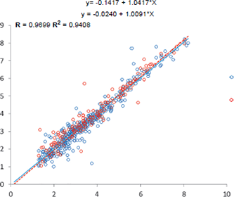
Of the 876 eligible subjects, 351 (40.1%) were female and 489 (55.8%) were male. The average age was 47.2 ± 15.9 years, with a range of 18 to 89 years. Of these 876 specimens, 560 were within the quantitation range of the both the Xpert HBV VL test and the comparator method. The result of the Deming regression and simple linear regression analyses are shown in Figure 14, which shows acceptable performance of Xpert HBV VL test compared to the comparator method for serum and EDTA-plasma specimen types with the slope close to 1, the intercept close to 0, and R ≥ 0.9699 and R2 ≥ 0.9408.

Deming Regression Linear Regression

Plasma

Serum

Comparator HBV Assay (Log10 IU/mL)

Figure 14. Correlation of the Xpert HBV VL Test vs. the Comparator Method using Serum and EDTA Plasma Specimens
Xpert HBV VL (Log10 IU/mL)
A total of 879 specimens from eligible subjects were tested by the Xpert HBV VL test. The Xpert HBV VL tests for 98.0% (861/879) of the eligible specimens were successful on the first attempt, yielding an initial non-determinate (ND) rate of 2.0% (18/879). Seventeen of the 18 indeterminate cases were retested, of which 15 yielded valid results upon repeat testing. The final ND rate was 0.3%.

Summary of Safety and Performance
Summary of Safety and Performance for this test is available on the EUDAMED website: (https://ec.europa.eu/tools/ eudamed).

References
- World Health Organization (WHO). Guidelines for the Prevention, Care and Treatment of Persons with Chronic Hepatitis B Infection. March 2015. Accessed March 14, 2018 at: http://www.who.int/hiv/pub/hepatitis/hepatitis-b- guidelines/en/.
- European Association for the Study of the Liver. EASL Clinical Practice Guidelines: Management of chronic hepatitis B virus infection. J. Hepat. 2012; 57:167-185. Available at: http://dxdoi.org/10.1016/j.jhep.2012.02.010.
- World Health Organisation. Global hepatitis report, 2017. WHO. April 2017.
- The 4th WHO International Standard for Hepatitis B Virus DNA for Nucleic Acid Amplification Techniques (NIBSC code: 10/266). National Institute for Biological Standards and Control; 2016.
- Centers for Disease Control and Prevention. Biosafety in Microbiological and Biomedical Laboratories (5th edition), accessed March 5, 2018 at http://www.cdc.gov/biosafety/publications/.
- Clinical and Laboratory Standards Institute. Protection of Laboratory Workers from Occupationally Acquired Infections, Approved Guideline. Document M29 (refer to latest edition).
- World Health Organization. Safe management of wastes from health-care activities. 2nd Edition. WHO, 2014. Accessed April 20, 2018 at http://www.who.int/water_sanitation_health/publications/wastemanag/en/.
- REGULATION (EC) No 1272/2008 OF THE EUROPEAN PARLIAMENT AND OF THE COUNCIL of 16
December 2008 on the classification labeling and packaging of substances and mixtures amending and repealing, List of Precautionary Statements, Directives 67/548/EEC and 1999/45/EC, and amending Regulation (EC) No 1907/2006.
- Occupational Safety and Health Standards, Hazard Communication, Toxic and Hazard Substances (March 26, 2012) (29 C.F.R., pt. 1910, subpt. Z).
- Clinical and Laboratory Standards Institute. Evaluation of Detection Capability for Clinical Laboratory Measurement Procedures; Approved Guideline – Second Edition. CLSI document EP17-A2. Clinical and Laboratory Standards Institute, Wayne, PA, 2012.
- Clinical and Laboratory Standards Institute. Evaluation of Precision of Quantitative Measurement Procedures; Approved Guideline – Third Edition. CLSI document EP05-A3. Clinical and Laboratory Standards Institute, Wayne, PA, 2014.
- Clinical and Laboratory Standards Institute. User Verification of Precision and Estimation of Bias; Approved Guideline – Third Edition. CLSI document EP15-A3. Clinical and Laboratory Standards Institute, Wayne, PA, 2014.
- Clinical and Laboratory Standards Institute. Evaluation of Linearity of Quantitative Measurement Procedures: A Statistical Approach. Approved Guideline. CLSI document EP06-A. Clinical and Laboratory Standards Institute, Wayne, PA, 2003.

Cepheid Headquarters Locations

Corporate Headquarters
Cepheid
904 Caribbean Drive
Sunnyvale, CA 94089 USA
Telephone: + 1 408 541 4191
Fax: + 1 408 541 4192
www.cepheid.com

Technical Assistance
Before Contacting Us
Collect the following information before contacting Cepheid Technical Support:
- Product name
- Lot number
- Serial number of the instrument
- Error messages (if any)
- Software version and, if applicable, Computer Service Tag number
Report serious incidents associated with the test to Cepheid and the competent authority of the member state in which the serious incident occurred.

United States Technical Support
Telephone: + 1 888 838 3222 Email: techsupport@cepheid.com

France Technical Support
Telephone: + 33 563 825 319 Email: support@cepheideurope.com
Contact information for all Cepheid Technical Support offices is available on our website: www.cepheid.com/en/support/ contact-us.

Table of Symbols

Symbol | Meaning
 | Catalogue number
 | In vitro diagnostic medical device
 | Do not re-use
 | Batch code
 | Consult instructions for use
 | Manufacturer
 | Country of manufacture
 | Contains sufficient for n tests
 | Control
 | Use-by date
 | CE Mark
 | Temperature limit
 | Biological risks
 | Skin corrosion, eye damage and corrosive to metals.
 | Country of Origin: USA
 | Country of Origin: Sweden
 | Authorized Representative in Switzerland
 | Importer

Cepheid AB Röntgenvägen 5
SE-171 54 Solna,
Sweden


Cepheid Switzerland GmbH Zürcherstrasse 66
Postfach 124, Thalwil CH-8800
Switzerland


Cepheid Switzerland GmbH Zürcherstrasse 66
Postfach 124, Thalwil CH-8800
Switzerland


2797

Revision History
Description of Changes: Initial release of 302-6823, Rev. A.

Revision | Effective | Description of Change
A | 04-2026 | Release of BSI approved 302-6823 Rev. 4 into production Rev. A.

